**CS-114 - Fundamental of Programing**

Lab Manual # 10

**Course Instructor:** Khawaja Fahad Iqbal

**Lab Instructor:** Muhammad Affan

**Student Name:** Muhammad Talha Kashif

**CMS ID:** 454135

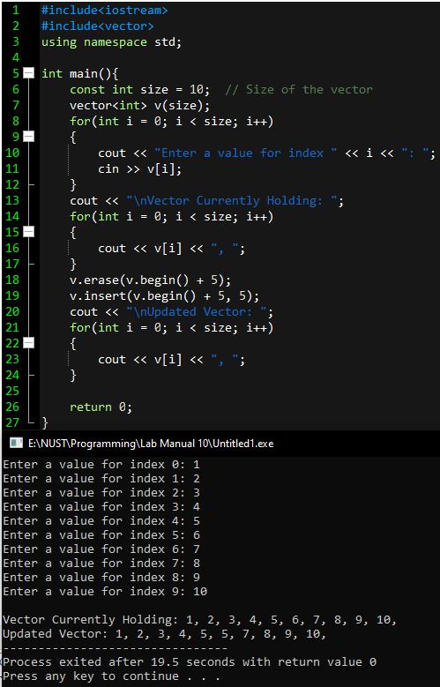

TASK 1

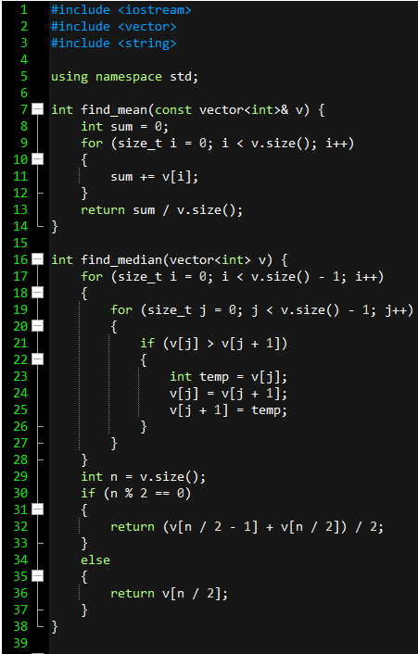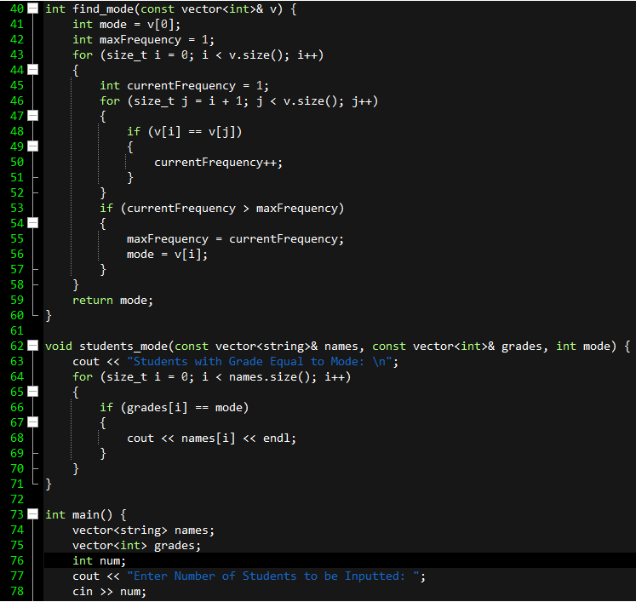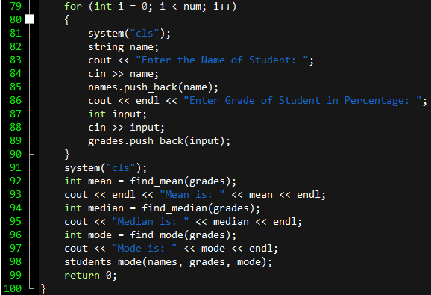

TASK 2



TASK 2

Asks for number of students then clears the console.



Asks name and grade of first student then clears the console.



Asks name and grade of second student then clears the console.



Asks name and grade of third student then clears the console.

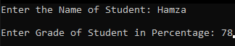

Asks name and grade of fourth student then clears the console.

